Name: Harsh Parmar

Roll Number: U23CS056

Topic:Hospital Mangament System

ER Diagram

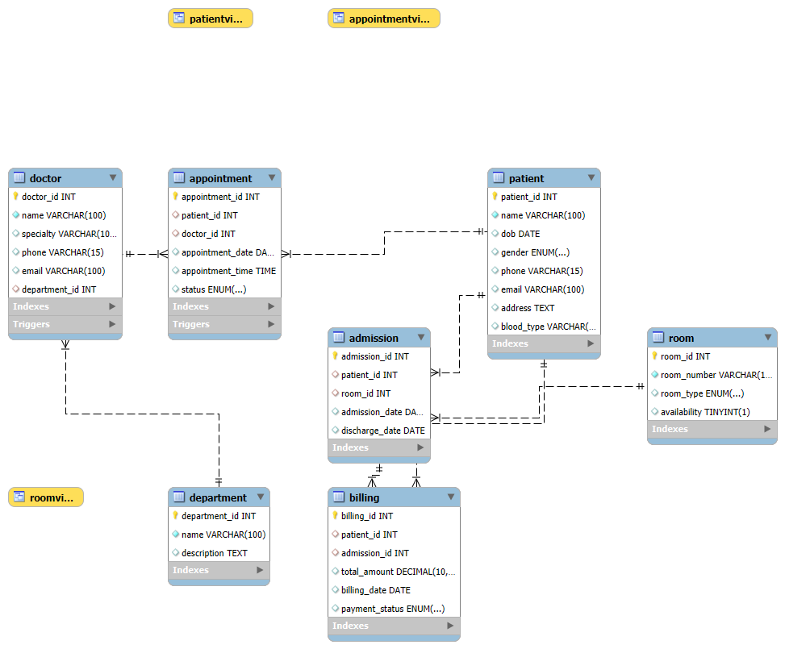

Code Link : https://github.com/harshparmar23/Hospital-management-system